Phil Crawley

TCP/IP for Broadcast Engineers

Gone are the days when every cable carried a synchronous video stream. Contemporary engineering staff have to be aware of packetized networks and how they impact the modern facility. This session covers the fundamentals of the protocols and practises that drive all internet-derived networks.

- History - why a packet-switched network?
- Layers - why they're important
- The OSI 7-layer model and why it’s not accurate!
- Protocols – UDP/IP and TCP/IP
- Routers, hubs, switches and how they differ
- Classes of networks
- Network Address Translation - NAT
- Tips & Tricks – broadcast packets, Ethernet speed, forwarding with Skype
History – Why Packet-switched networks?
Packet switching is a digital network communications method that groups all transmitted data – irrespective of content, type, or structure – into suitably-sized blocks, called packets. This all dates back to the prototype internet of the 1960s – ArpaNet.
Packet switching features;
- Delivery of variable-bit-rate data streams (sequences of packets) over a shared network
- Switches, routers and other network nodes buffered and queue packets
- Variable delay and throughput depending on the traffic load in the network.
Advantages;
- No dedicated circuits. Data units do not have to follow the same route.
- Each circuit carries many different transmissions at the same time.
Disadvantages;
- Every data unit sent through a packet-switching network must have enough information in the header that the nodes in the network can determine how to route the data unit. This tends to add overhead to the data unit, but the trade-off is well invested.
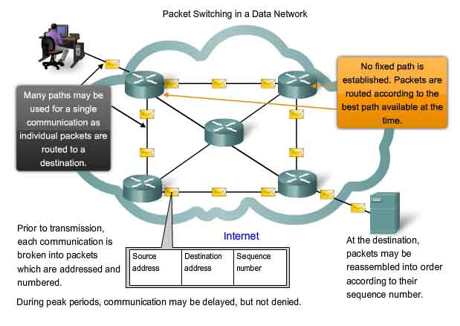
Layers – why are they important?
The layered concept of networking was developed to accommodate changes in technology. Each layer of a specific network model may be responsible for a different function of the network. Each layer will pass information up and down to the next subsequent layer as data is processed.
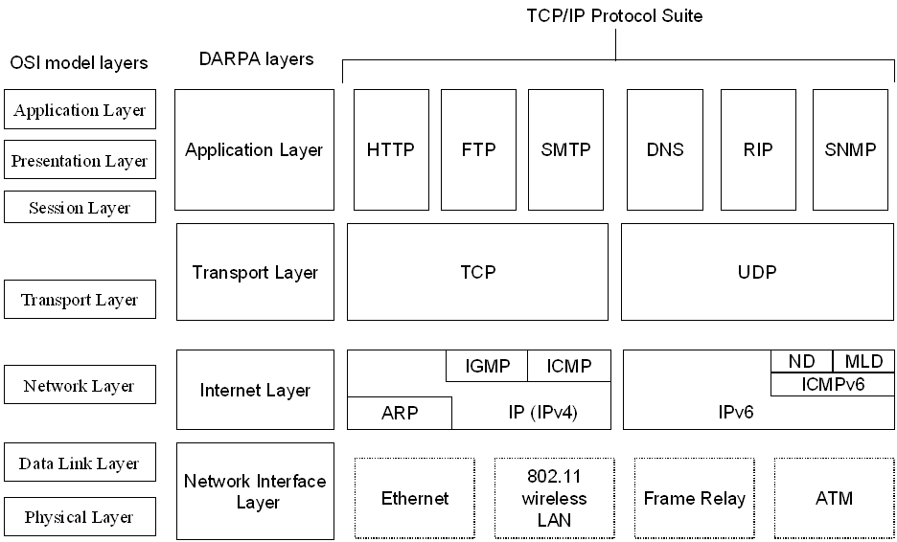
Why the OSI 7-layer model is not too useful!
Even though the concept is different than in OSI, the Cisco/Arpanet layers are nevertheless often compared with the OSI layering scheme in the following way:
- The Internet Application Layer includes the OSI Application Layer, Presentation Layer, and most of the Session Layer.
- Its end-to-end Transport Layer includes the graceful close function of the OSI Session Layer as well as the OSI Transport Layer.
- The internetworking layer (Internet Layer) is a subset of the OSI Network Layer,
- Link Layer includes the OSI Data Link and Physical Layers, as well as parts of OSI's Network Layer.

These comparisons are based on the original seven-layer protocol model as defined in ISO 7498, rather than refinements in such things as the internal organization of the Network Layer document.
IT people get very hung-up on the seven layer model, but four layers are enough for anyone!
The four layer ‘Cisco Academy’ or Arpanet model – some detail;

- The Link layer corresponds to the hardware, including the device driver and interface card. The link layer has data packets associated with it depending on the type of network being used such as ARCnet, Token ring or ethernet. In our case, we will be talking about ethernet.
- The network layer manages the movement of packets around the network. It is responsible for making sure that packages reach their destinations, and if they don't, reporting errors.
- The transport layer is the mechanism used for two computers to exchange data with regards to software. The two types of protocols that are the transport mechanisms are TCP and UDP.
- The application layer refers to networking protocols that are used to support various services such as FTP, Telnet, WWW, etc. However a program that you may write can define its own data structure. For example when your program opens a socket to another machine, it is using TCP protocol, but the data you send depends on how you structure it.
IP addresses
The thing that all hosts (computers, servers, embedded devices etc) need to communicate on the Internet (or any IP LAN) is an IP address:
how many IP addresses are there?
- 192.168.0.22
- 83.56.123.78
Additionally each host on the network will have a subnet mask which dictates the class of the network (we’ll come to that later) – in most of the small networks you’ll deal with expect to find hosts assigned to a C-Class network with a subnet mask:
- 255.255.255.0
IP addresses are different from MAC (Media Access Control) addresses (AKA H/W address):
- 01-23-45-67-89-ab

MAC addresses are unique and should be unique to each piece of equipment.
Ports
As well a unique IP address a machine will send and receive internet traffic on ports – these are a virtual construct and allow segregation of traffic for different services. Typical ports used might be:

- 80 The standard port for web traffic
- 21 The File Transfer Protocol port FTP
- 135-139 & 445 Windows file sharing protocol (SMB)
- 5900 The VNC remote control protocol

Generally the ‘low-order’ ports (1-1024) are reserved for defined protocols and all ports above 1024 are less well defined and can be used for whatever purpose you want.
Types of Protocols – UDP/IP and TCP/IP
IP has these concepts of connection and connectionless communication. Although there are many kinds of IP packets defined the ones you’ll come across the most are UDP (User Datagram Protocol) and TCP (Transmission Control Protocol).
TCP operations may be divided into three phases.
- Connections must be properly established in a multi-step handshake.
- Data transfer phase.
- After data transmission is completed, the connection termination closes established virtual circuits and releases all allocated resources.
Due to network congestion, traffic load balancing, or other unpredictable network behaviour, IP packets can be lost, duplicated, or delivered out of order. TCP detects these problems, requests retransmission of lost packets, rearranges out-of-order packets, and even helps minimize network congestion to reduce the occurrence of the other problems. Once the TCP receiver has finally reassembled a perfect copy of the data originally transmitted, it passes that datagram to the application program. Thus, TCP abstracts the application's communication from the underlying networking-details. The user (or even the programmer) need not be aware of the underlying plumbing. One developer I know insists that real men should avoid TCP!
UDP/IP dispenses with all the heavy lifting that TCP provides and offers a more lean’n’mean method of communication.
This provides the application multiplexing and checksums that TCP does, but does not handle building streams or retransmission giving the application developer the ability to code those in a way suitable for the situation and/or to replace them with other methods like forward error correction or interpolation.

- Streamed media – Internet radio etc where packets arriving out of order is worse than packet loss.
- DNS – the domain name system has to be lightweight with little need for handshaking.
- DHCP & RIP – the protocols used to welcome a machine onto a LAN and provide it with all the settings it needs to communicate properly ahead of getting an IP address.

Typically UDP/IP can be thought of as the utility protocol that undergirds the Internet and all IP-based LANs.
Before we proceed – the structure of a TCP/IP packet;
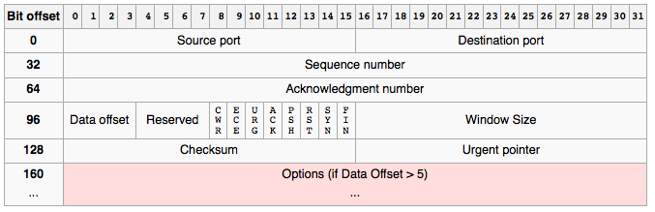
Stolen from Wikipedia
The protocol allows for variable-sized data payloads as network conditions dictate – on a very quiet local-area network packet size may extend to 64k bits but extensions to the protocol allow for hundreds of megabytes!
The three-way TCP handshake;
To establish a connection, TCP uses a three-way handshake. Before a client attempts to connect with a server, the server must first bind to a port to open it up for connections: this is called a passive open. Once the passive open is established, a client may initiate an active open. To establish a connection, the three-way (or 3-step) handshake occurs:
- The active open is performed by the client sending a SYN to the server. It sets the segment's sequence number to a random value A.
- In response, the server replies with a SYN-ACK. The acknowledgment number is set to one more than the received sequence number (A + 1), and the sequence number that the server chooses for the packet is another random number, B.
- Finally, the client sends an ACK back to the server. The sequence number is set to the received acknowledgement value, and the acknowledgement number is set to one more than the received sequence number i.e. B + 1.

At this point, both the client and server have received an acknowledgment of the connection. This also means it is nigh on impossible to spoof an IP address on the internet as the return from the handshake would not arrive back at the originating host.
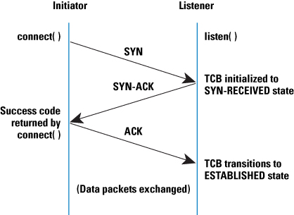
Real world example – PC connects to a router and starts a web-browser session;
- Computer powers up, OS loads (including n/w card driver and IP stack) and acquires network settings;

- The operating system issues a DHCP request over UDP/IP – remember at this point the PC has no IP address so it uses the ‘broadcast’ address of 255.255.255.255 – DHCP Discovery
- The router (or in the case of a larger network, the DHCP server) responds with the offer of an IP address - DHCP Offer
- The operating system issues an acknowledgement over UDP/IP with the IP address (in case multiple DHCP servers answered the call, they can hang onto those IPs) – DHCP Request
- The router (or DHCP server) responds with other details (DNS etc) and the lease time – how long the IP address is good for- DHCP Acknowledge

The computer now has all the information it needs to communicate with the local area network and (via the router) out to the Internet.
Real world example – PC connects to a router and starts a web-browser session;
- Computer runs a web browser and requests www.root6.com

- WRT our four layer model Firefox (running at the application layer) requests the web page.
- The transport layer of the OS’s IP stack checks to see if it has a recent record of having visited that site and if not issues a DNS request to the internet layer
- The network layer sends the request out (over the appropriate interface – ethernet cable or WiFi) to the router (over UDP/IP, port 53)
- The router sends the DNS request out (over its internet-facing interface – aDSL or cable) to the ISP’s upstream DNS router (over UDP/IP, port 53) and takes a note of which computer made the request.
- The ISP’s DNS server checks to see if it has a recent record of that site and if not it passes the request on to the next higher-order DNS server – eventually www.root6.com gets turned into 193.203.84.196 which the PC can do something with!
- The router gets the result of the DNS lookup and returns it to the PC (UDP, port 53)
Real world example – PC connects to a router and starts a web-browser session;
- Computer now knows the IP address of the page it needs and can fetch it
- The transport layer of the OS’s IP stack issues a request for the web page to the internet layer using the newly acquired IP address. This forms the start of a TCP session
- The network layer sends the request out (over the appropriate interface – ethernet cable or WiFi) to the router (now over TCP/IP, port 80)
- The router sends the web page request out (over its internet-facing interface – aDSL or cable) to 193.203.84.196 (TCP/IP, port 80) and takes a note of which computer made the request. ISP & other routers send the packets on their way – beyond the ‘scope of today!
- The server at 193.203.84.196 receives the request on it’s port 80 (via it’s network, internet, transport and application layers) and returns the HTML file that makes the page.
- The router (eventually!) gets the packet(s) over port 80 and (knowing who requested the packets) returns them (over port 80 TCP) to the PC.
- The IP stack on the PC returns the packet up the network, internet, transport and finally application layers allowing the browser to start building the page!

The previous example is simplified and doesn’t include;

- The ‘heavy lifting’ protocols like BGP (Border Gateway Protocol) which allow the packets to traverse the public internet.
- The unavoidable TCP/IP retries as packets are lost.
- The ARP (Address Resolution Protocol) table that the router has to build and maintain to know what IP addresses match to MAC addresses.
- Any additional negotiation that goes on if the PC is on a wireless network.

But if you can follow the simplified example you will now be aware of the hundreds of transactions and thousands of packets that have to travel to build a single web page.
One concept that is important to read further on is TCP sessions
Classes of networks and IP addresses space
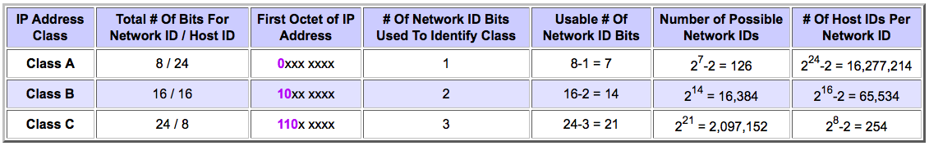
The Internet was originally designed as a ‘classful’ network where (to aid routing when embedded network devices were slow/expensive) every IP address would imply routing by the class of it’s network.

In the case of a B-Class network the basic division is into 16 bits for network ID and 16 bits for host ID. However, the first two bits of all class B addresses must be "10”, so that leaves only 14 bits to uniquely identify the network ID. This gives us a total of 214 or 16,384 class B network IDs. For each of these, we have 216 host IDs, less two, for a total of 65,534.
In the early years the Internet Assigned Numbers Authority handed out A and B class networks too readily leading to what was perceived a great shortage of IP addresses in the mid 90’s until we were saved by.....
Network Address Translation
In the mid-1990s NAT became a popular tool for alleviating the fact that the world was running out of IP addresses. Your office or home computer will likely have an address like 192.168.0.3 which clearly could not be routed across the internet.

- Most systems using NAT do so in order to enable multiple hosts on a private network to access the Internet using a single public IP address (as a gateway). However, NAT breaks the originally envisioned model of IP end-to-end connectivity across the Internet, introduces complications in communication between hosts, and affects performance.
- NAT obscures an internal network's structure: all traffic appears to outside parties as if it originated from the gateway machine. NAT routers are by their nature superb firewalls as they turn away unrequested packets and stop unsolicited traffic from entering a network.
- Network address translation involves re-writing the source and/or destination IP addresses and usually also the TCP/UDP port numbers of IP packets as they pass through the NAT. Checksums (both IP and TCP/UDP) must also be rewritten to take account of the changes.
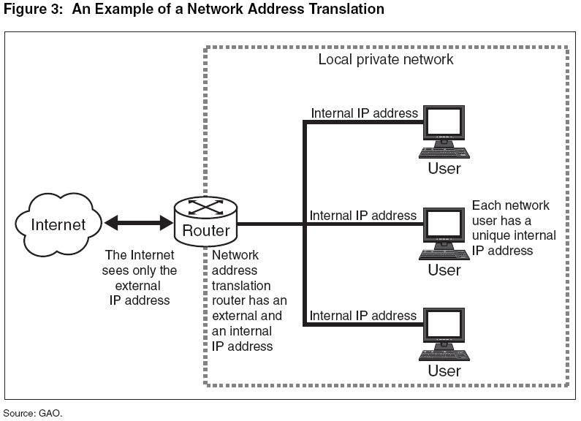
Routers, hubs, switches and how they all differ;

- A router is a networking device whose software and hardware are usually tailored to the tasks of routing and forwarding information. Routers connect two or more logical subnets.
- A network which is generally optimized for Ethernet LAN interfaces and may not have other physical interface types. The switch maintains an ARP table which keeps a record of all of the MAC addresses on the network and learns which ports to switch traffic to. Initially then the switch powers up it behaves as a Hub.
- Hub (predecessor of the "switch" or "switching hub") does not do any routing, instead every packet it receives on one network line gets forwarded to all the other network lines.

The term "layer 3 switching" is often used interchangeably with routing, but switch is a general term without an exact technical definition. Hubs are increasingly rare.
There is a world of difference between the domestic aDSL/cable/wireless router and a data-centre type devices and small 8-port Ethernet switches and enterprise switches. However, in a very real sense you can regards your home or small office network as a microcosm of the Internet.
Tips and Tricks

The 224.0.0.0/4 multicast subnet

If you're ever in a position where you need to identify a device's IP address (even on a different subnet, but the same LAN segment) you can PING 224.0.0.1 and everything on the segment will respond to the PING (firewall settings permitting).

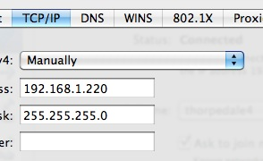

So, if I set my machine's IP address to 192.168.1.220 on a 10.100.100.x network and then PING the multicast address;

This comes in very useful with Amulet DXiP cards which you configure over a web interface. Our demo kit came back from a customer who had forgotten what they had hard-set the cards' IP addresses to and this technique was a life-saver.

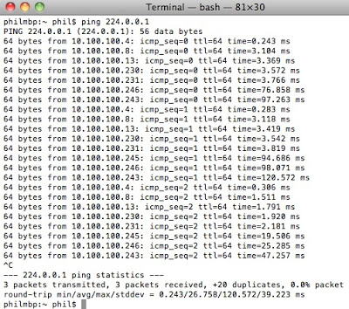

You can see that all the machines on the 10.100.100.0/8 network respond.

Ever need to slow down ethernet?

I've had a few occasions when I've had to force gigabit down to 100BaseT or even 100 down to 10BaseT. My preferred method is to force the NIC down to the appropriate speed but if you aren't using Windows (OS-X, Linux or an embedded device) then a hardware solution is needed.
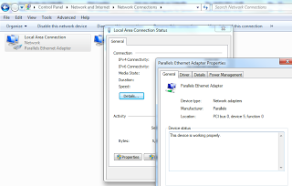
- Distance - 100BaseT only goes 100m over cat5e but 10BaseT goes 300m; If you find yourself in that situation then an old 10BaseT hub at the far end does the job.
- Equipment reports 100BaseT but is only reliable at 10BaseT; my Squeezebox network MP3 player is running a hacked OS and works a lot more reliably at 10BaseT. I achieved this by swapping the green/white and orange cores in the network cable. This degrades the common-mode rejection performance of the cable and means the ethernet switch ramps the circuit down to 10BaseT.
- Gigabit too fast? Just make off a cable with the blue and brown pairs excluded. Gigabit needs all four pairs and if the switch only sees the Green and Orange pairs it will assume 100BaseT.
Port forwarding to help Skype

One of the things I found makes a difference is forwarding the port you particular Skype installation has randomly chosen. The reason for this is that we pretty much all live behind NAT routers and for a peer-to-peer protocol to work you need some users to be supernodes
The Skype system automatically selects certain users with fast CPUs, good broadband connections and no firewall issues to be "supernodes", through which other users may connect. Skype can therefore utilise other users' bandwidth. There are some 20,000 supernodes out of many millions of users logged on.
So if you're communicating with another Skype user and having to traverse two NAT routers (his and yours) the call has to go via a supernode - the two routers have no way of letting each other know what Skype ports are required to be left open. The way to avoid this is to port-forward your Skype port in your router and then there is only one NAT taversal taking place. Now if you run your network DHCP then you may have to set the MAC address of your PC to always get dished the same IP address, but once that's done it's trivial to look up the port being used (in Skype's Option>Connection settings) and then set that as a static UDP route in your Netgear/DLink/whatever box. If you have more than one Skype client then you need to repeat the process for each computer - but since Skype allocated a random UDP port on install (in the range 1024-65535) it is unlikely you'll get two the same on a class-C subnet.
The good thing about this is that once you've done it you'll enjoy better throughput with any other Skype user - they don't need to have even have heard of port forwarding.
